QUESS CORP LIkIITED

HEAD OFFICE - 3/3/2,QUESS TOWER, SKY WALK AVENUE, 32/4, SERVICE ROAD, MUNESWARANAGAR, ROOPENA AGRAHARA, BOMMANAHALLI, BENGALURU, KARNATAKA,

w ia ui If 0 TO 0 ETn Ee

 | 2002476889 |  | 3314456857
 | ATHARV SUNIL SUPEKAR |  | 31.00
DATE OF JOINING  DESIGNATION DEPUTED AT | 21/03/2023  LOGISTICS EXECUTIVE  REXEL INDIA PRIVATE LIMIT E D | BANK A/C NO | 31.00  HDFC BANK 50100733776090
 |  | INSURANCE NO | BLR-NC-Q0091-001-0011983-A
 |  | LOCATION
 | PY KRP00139920000349023  101929236802 |  | QS3016b62  0.00

BASIC |  | PROVIDENT FUND
HOUSE RENT ALLOWANCE | 7,517.00 | PROFESSIONAL TAX | 20000
OTHER ALLOWANCE | 3,531.00
STAT UTORY_BONUS

BASIC | 99 400 | 70700 | 170100 | ACCOMODATION
HOUSE RENT ALLOWANCE |  | 37585
OTHER ALLOWANCE | 29484 | 17655 | 47139 | OTHER
STAT UTORY_BONUS |  | 5890 |  | PREVIOUS EMPLOYER | INCOIvIE

DEDUCTION U/S 16 (PROFESSIONAL TAX) DEDUCTION U/S 16(IA) (STANDARD DEDUCTION) DEDUCTION UNDER CHAPTER VI-A
DEDUCTIONS U/S (1 0) AND (17) DEDUCTIONS UNDER CHAPTER VI (SEC 80)
EDUCATION CESS
75000 SECTION 87 RELIEF

TAX ON INCOME
TAX ON INCOME BLESS 87 RELIEF]

TAX RECOVERED
TAXABLE INCOME (NET SALARY - DEDUCTIONS)

NOTE: THIS IS A COMPUTER GENERATED DOCUMENT DOES NOT REQUIRE ANY SIGNATURE

FOR ANY OUERY, PLEASE REACH US @ 1800-572-3333 OR WRITE TO HELP@QUESSCORP.COM

248664

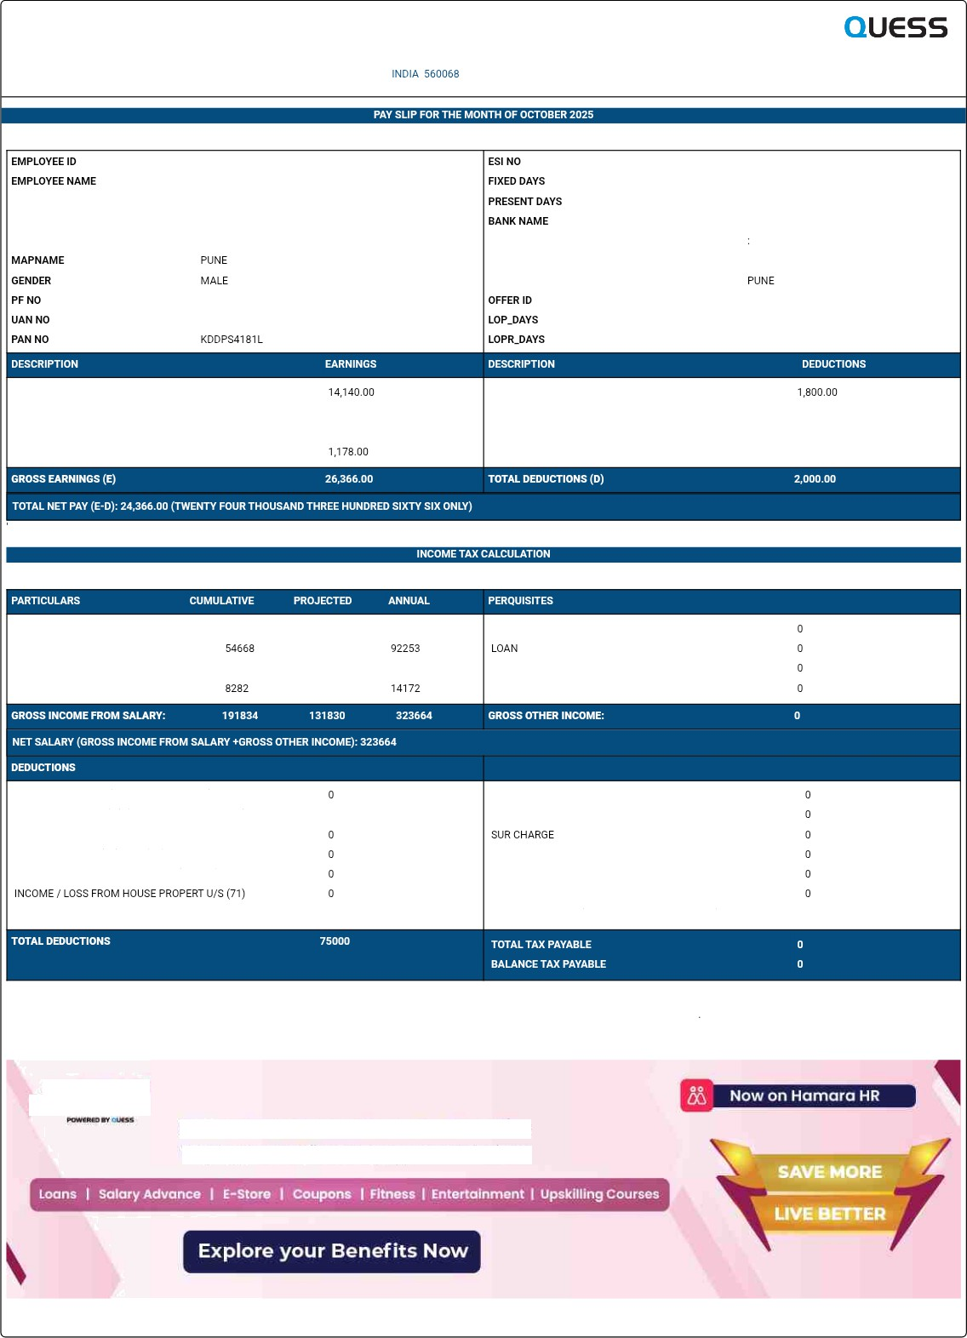


Quess introduces Hamoro Ber›eflts
Employee Benefits 6‹ Engagement Platform

N0V 8 2025 3:2 BPM

